Information about Jack the Ripper QUESTIONS TO ANSWER AT THE END

No one knows who Jack the Ripper was. And no one knows for certain what motivated him (Abrahamsen, 1992). But he was, in a macabre way, a man for his times. The turmoil of the Industrial Revolution in Britain upset the standard social order, generating new ambitions, conflicts, and frustrations. Urbanization, crowding, and change led to anomie and the creation of the alienated loner. Harsh and inhumane conditions, an indifference towards children, and a savage lifestyle all conspired to create an environment conducive to violence and sexual deviance. It is not surprising the psychological and social infrastructures of the nineteenth century produced the first modern serial killer (Leyton, 1986).
Many of the rookeries in Victorian London were demolished during a series of social reforms. But the slums of Whitechapel and Spitalfields survived and predictably endured an influx of criminals displaced by the city's urban renewal (see Brantingham & Brantingham, 1984). The late 1800s saw almost a million people dwelling in the slums east of Aldgate Pump; 4,000 houses in Whitechapel alone one year were condemned as uninhabitable, though little was done about it for years (Rumbelow, 1988). Liquid sewage filled the cellars of houses and people kept their windows – those not yet broken – shut because of the stench from without. The majority of families, often up to nine people, lived in one room. Incest was common in these crowded conditions, even amongst children as young as 10.
Many East End youth died before they were five. It would not be unusual for a mother to send her young children into the streets until after midnight, while she engaged in the business of prostitution to make sufficient money to feed them. Often children fell off their seats at school from exhaustion or cried from the pain of chronic starvation. Yet these unfortunates at least had a home. Many others slept on the streets or in dustbins, under stairways or bridges. Those who managed to scrape together enough money could rent a room in a lodging house, and such buildings held 8,500 nightly in Whitechapel. Within these doss houses flea-infested wallpaper hung in strips and stairway handrails were missing, long ago burnt for firewood. If you could not afford a straw mattress, two pence bought you the privilege of a place along a rope to lean against and sleep (Rumbelow, 1977).
Women's work included scrubbing, sweatshop tailoring, hop picking, and sack or matchbox making, all with a complete lack of safety standards. Seventeen hours of backbreaking labour paid 10 pence, less the cost of materials. Prostitution was a viable alternative, paying anywhere from a loaf of stale bread to three pence. It was estimated that one woman in 16 engaged in this trade, for a total of 1,200 prostitutes in Whitechapel and 80,000 in London (Rumbelow, 1988). The environment in the slums of London was such that Irish playwright George Bernard Shaw commented, after the second of the Ripper killings, that perhaps “the murderer was a social reformer who wanted to draw attention to social conditions in the East End” (C. Wilson, 1960, p. 60).
Little is known about Jack the Ripper beyond his handiwork. The first canonical murder took place on Bank Holiday, Friday, August 31, 1888, in Buck's Row. The victim was Polly Nichols, a 42-year-old alcoholic with grey hair and five missing front teeth. She had five children from a broken marriage. The Ripper cut her throat from ear to ear, back to the vertebrae, and sliced open her abdomen from pelvis to stomach. The autopsy found she sustained stab wounds to the vagina (Howells & Skinner, 1987).
The next killing took place in a yard at No. 29 Hanbury Street, on Saturday, September 8, 1888. Annie Chapman was 45 years of age, stout, pugnacious, and missing two of her front teeth. An alcoholic, she was separated from her husband and two children, one of them a cripple. She was found with her neck cut so deeply it appeared as if an attempt had been made to take off her head. Her abdomen was laid open and her intestines placed on her shoulder. Parts of her vagina and bladder had been removed.
On Sunday, September 30, 1888, a double murder occurred. The Ripper first attacked Elizabeth Stride in a courtyard next to the International Working Men's Educational Club on Berner Street. Stride was a 45-year-old alcoholic missing her front teeth and the roof of her mouth. She bore nine children, but claimed her husband and two offspring had perished in a steamboat disaster. The Ripper had cut her throat, severing the windpipe. The mutilation was minimal as he was interrupted by a carriage entering the courtyard.
Within the hour a second body was discovered in Mitre Square, in the City of London. Catherine Eddowes, 43 years, was, like her fellow victims, an alcoholic with a broken marriage. She carried all her worldly possessions in her pockets. Her throat was deeply cut, and her abdomen laid open from breast downwards, the entrails “flung in a heap about her neck.” Her ear was almost cut off and a kidney taken, the latter apparently later mailed to the authorities.
The final and most horrific murder occurred in 13 Miller's Court, on Friday, November 9, 1888. Mary Kelly, only 20 years of age and three-months pregnant, was already a widow with alcohol problems. A bizarre sight greeted those who discovered her body. Her head and left arm were almost severed, her breasts and nose cut off, thighs and forehead skinned, entrails wrenched away, and her body parts piled on the bedside table. Jack the Ripper had all the time he needed to satiate his bizarre desires in Miller's Court, and while debate continues on whether he was responsible for other prostitute murders that occurred around this time, most investigators believe he stopped, for whatever reason, after the mutilation of Mary Kelly (Wilson & Odell, 1987).
The geographic concentration of the Ripper crimes has long made their “topography” of interest to researchers (Fido, 1987). The murders were all within a mile of each other, and the total hunting area was just over half a square mile in size. In 1998 a geographic profile was produced for the Jack the Ripper case based on body dump sites. The peak area of the geoprofile focused on the locale around Flower and Dean Street and Thrawl Street.
Flower and Dean Street and Thrawl Street no longer exist as they used to, but in 1888 they lay between Commercial Street to the west and Brick Lane to the east, north of Whitechapel Road; during the time of the Whitechapel murders they contained several doss houses. Dorset Street lay less than two blocks to the north along Commercial Street. This was the vice-ridden neighbourhood that East End social reformers referred to as the “wicked quarter-mile” (Begg, Fido, & Skinner, 1991). It appears that the notorious rookery played a key role in the Jack the Ripper mystery, and there is some supporting evidence for the geographic profile results.
All the victims resided within a couple of hundred yards of each other in the Thrawl, Flower and Dean, Dorset, and Church Street doss houses off Commercial Street (Fido, 1987; Underwood, 1987):
• Polly Nichols used to reside at 18 Thrawl Street; just before her death she was evicted and moved into the White House at 56 Flower and Dean Street, a doss house that slept both men and women.
• Annie Chapman's primary residence was Crossingham's Common Lodging House at 35 Dorset Street.
• Elizabeth Stride occasionally lived in a common lodging house at No. 32 Flower and Dean Street, and reportedly was there the night of her murder.
• Catherine Eddowes usually stayed in Cooney's Lodging House at No. 55 Flower and Dean Street, and had slept there two nights before her murder.
• Kelly lived and died in McCarthy's Rents at 13 Miller's Court, off Dorset Street (it was actually the back room of 26 Dorset Street, situated across the road from Crossingham's Common Lodging House). She had previously resided in George Street, between “Flowery Dean” and Thrall Street. Kelly was seen picking up a man on Commercial Street between Thrall and Flower and Dean Streets the night of her murder.
These residences were suspiciously close to each other, covering less than 1.5% of the total hunting area. It is difficult to assess the significance of this finding as the locale had a concentration of slum lodging houses where most Spitalfields Parish prostitutes lived at one time or another. These women were also highly transient.
Two blocks north of Flower and Dean Street was the Ten Bells Pub (now known as the Jack the Ripper Public House) on Church Street and Commercial Street, across from Spitalfields Market; all the Ripper victims were known to have drank here. Possibly Whitechapel Road and Commercial Street/Road were arterial routes used by the killer.
Part of Eddowes' blood-stained apron was cut away by her killer, and the missing segment was later found in the passageway to a staircase for the Wentworth Model Dwellings, No. 108-119 Goulston Street. Located just south of Wentworth Street, the new flats were one-third of a mile away and a 10-minute walk from Mitre Square where Eddowes was murdered. It appeared the bloodied apron piece was used to wipe clean a knife. The following graffito was written in chalk above on the black brick wall (Rumbelow, 1988):
The Juwes are not
The men that
Will be
Blamed for nothing
Source: Rossmo, D. K. (2000). Geographic Profiling. Boca Raton, FL : CRC Press.

JACK THE RIPPER – FORENSICS DAY 1 DEBRIEF QUESTIONS
Look at the map of where Jack’s five canonical victims and potential others were murdered.
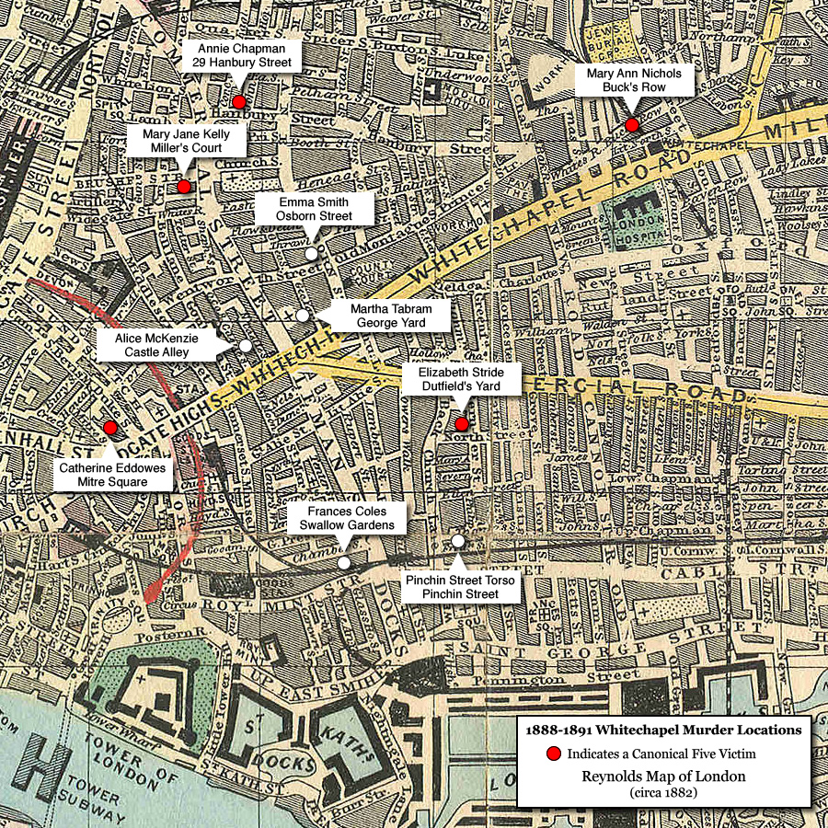
Where do you think Jack the Ripper may have lived? Where do you think his next murder might have occurred if he had committed one?
Now look at the Jack the Ripper PowerPoint (on Moodle) showing you letters (that may or may not have been written by him) and photos related to the murders (NOTE – SOME GRAPHIC IMAGES)
What do Jack’s victims and modus operandi (the way he murdered) tell you about him? What do you think he may have been like as a person? (E.g. confident, rude, smart etc.) What job did he do? (based upon the way he killed) What was his background? (considering where he lived and his choice of victims) What were his family like? (Again this may influence his decision to kill and choice of victims) How educated was he? (was it a clever crime and did he write the letters?)

WHICH KILLER LOOKS MOST LIKE THE RECENT POLICE E-FIT (TOP LEFT IMAGE) OF JACK?