Year 13 Listening

John Cage – Concerto for Prepared Piano and Chamber Orchestra

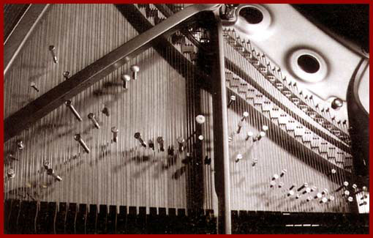
American avant-garde composer John Cage (1912–1992) started composing for prepared piano in 1940.

Screws, bolts, plastic and rubber were inserted in the strings of the piano to completely alter the timbre.

Q – What effect does the timbre of the prepared piano have in this piece?
How is this piece typical of the Avant Garde style?

