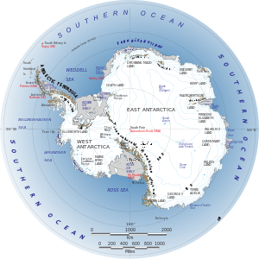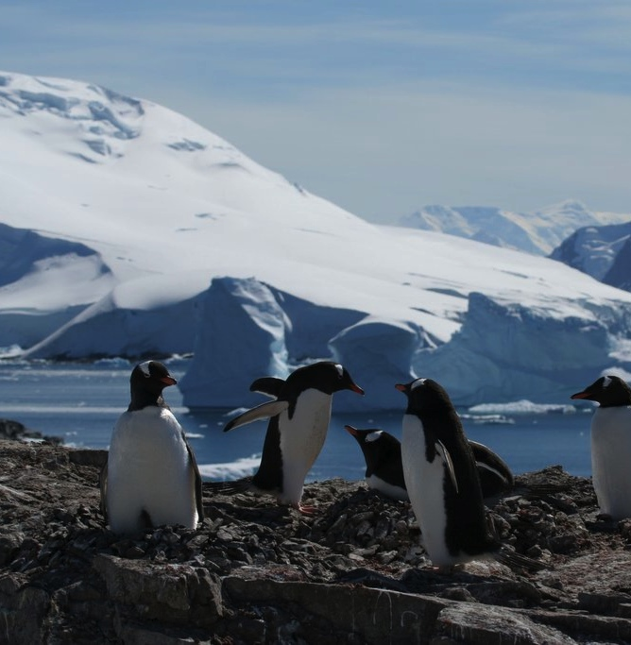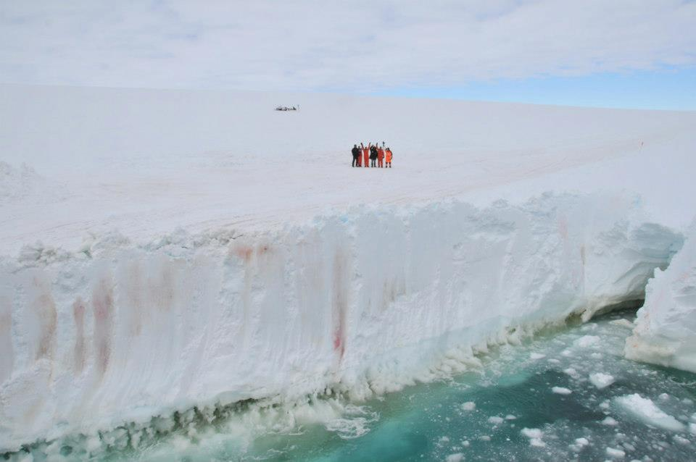

Session 2

Introduction to Mapping Antarctica

Monday 11th February 2013

3.35 – 5.00pm Room 40

Introduction to Project 2: Bacteria in Extreme Temperatures

# Next Session

The aim of the project is to allow students to engage with the progress of the main expedition and to be inspired by the landscape, environment and research in Antarctica. We are aiming to conduct research of our own in parallel with the official expedition. We hope to receive information from the project that will enable our students to analyse groundbreaking scientific data at the forefront of cutting-edge science. We will be undertaking projects under the expedition's four research objectives. These wide-ranging headings allow for cross-curricular links between the expedition and many departments within the school and the students will have the opportunity to engage in activities from art projects to nutrition challenges and from digital mapping to chemical analysis. We will be documenting our work in a regular journal for pupils and parents.

## Aim of the Project

Mr R Pletts, Head of Geography

Mr R Mundy, Biology

Monday 4th February 2013

Coldest Journey Club

#### Sutton Grammar School Presents:

# Contributors:

# Produced by SGS Coldest Journey Club

© Sutton Grammar School, January 2013

We will be continuing to produce our own team biographies (once we have allocated roles to members of the team) as the real expedition team has done here - <http://www.thecoldestjourney.org/home/expedition/biographies/>

Expedition Latest Progress

*The ice team members have now been left to themselves on the ice having finished offloading equipment in preparation for the start of the crossing on 21st March 2013*

*Photo, right © The Coldest Journey*

# Team Roles and Project Planning

We will be allocating roles to members of the group and planning will begin as to how we will research similar topics to that of the expedition out in Antarctica. We will also look at how these various projects fit into a timetable between January and September.

### Coldest Journey Expedition [www.thecoldestjourney.org](http://www.thecoldestjourney.org)

Crossing the Antarctic during winter will provide a unique opportunity to collect key scientific data to further our understanding of the effects of climate change, and advance other important areas of research.

During the traverse, the expedition team will carry out a number of important tests which will include mapping the height of the landmass using new GPS techniques, sampling surface snow to establish patterns of large-scale atmospheric transport of water vapour across the ice sheet, and sampling for cryo-bacteria capable of withstanding the extreme cold conditions.

### Sutton Grammar Club Related Aim for this week

Objectives:

* to continue to put together a team and organize the upcoming activities.
* to begin research into the features of Antarctica and to propose a methodology for producing maps of the continent.
* to report the team’s findings by publicizing to school, parent and wider community including expedition team.

# Introduction to Mapping

# Team Biographies

We will be deciding on methodology for researching the features of the Antarctic. We will be considering sources of information and considering our aim for the maps that we produce.

Background

Session Plan

**Sutton Grammar School**  
Manor Lane  
Sutton, Surrey SM1 4AS

[www.suttongrammar.sutton.sch.uk](http://www.suttongrammar.sutton.sch.uk)

@SGSgeography on Twitter and SGSgeography Channel on YouTube for updates